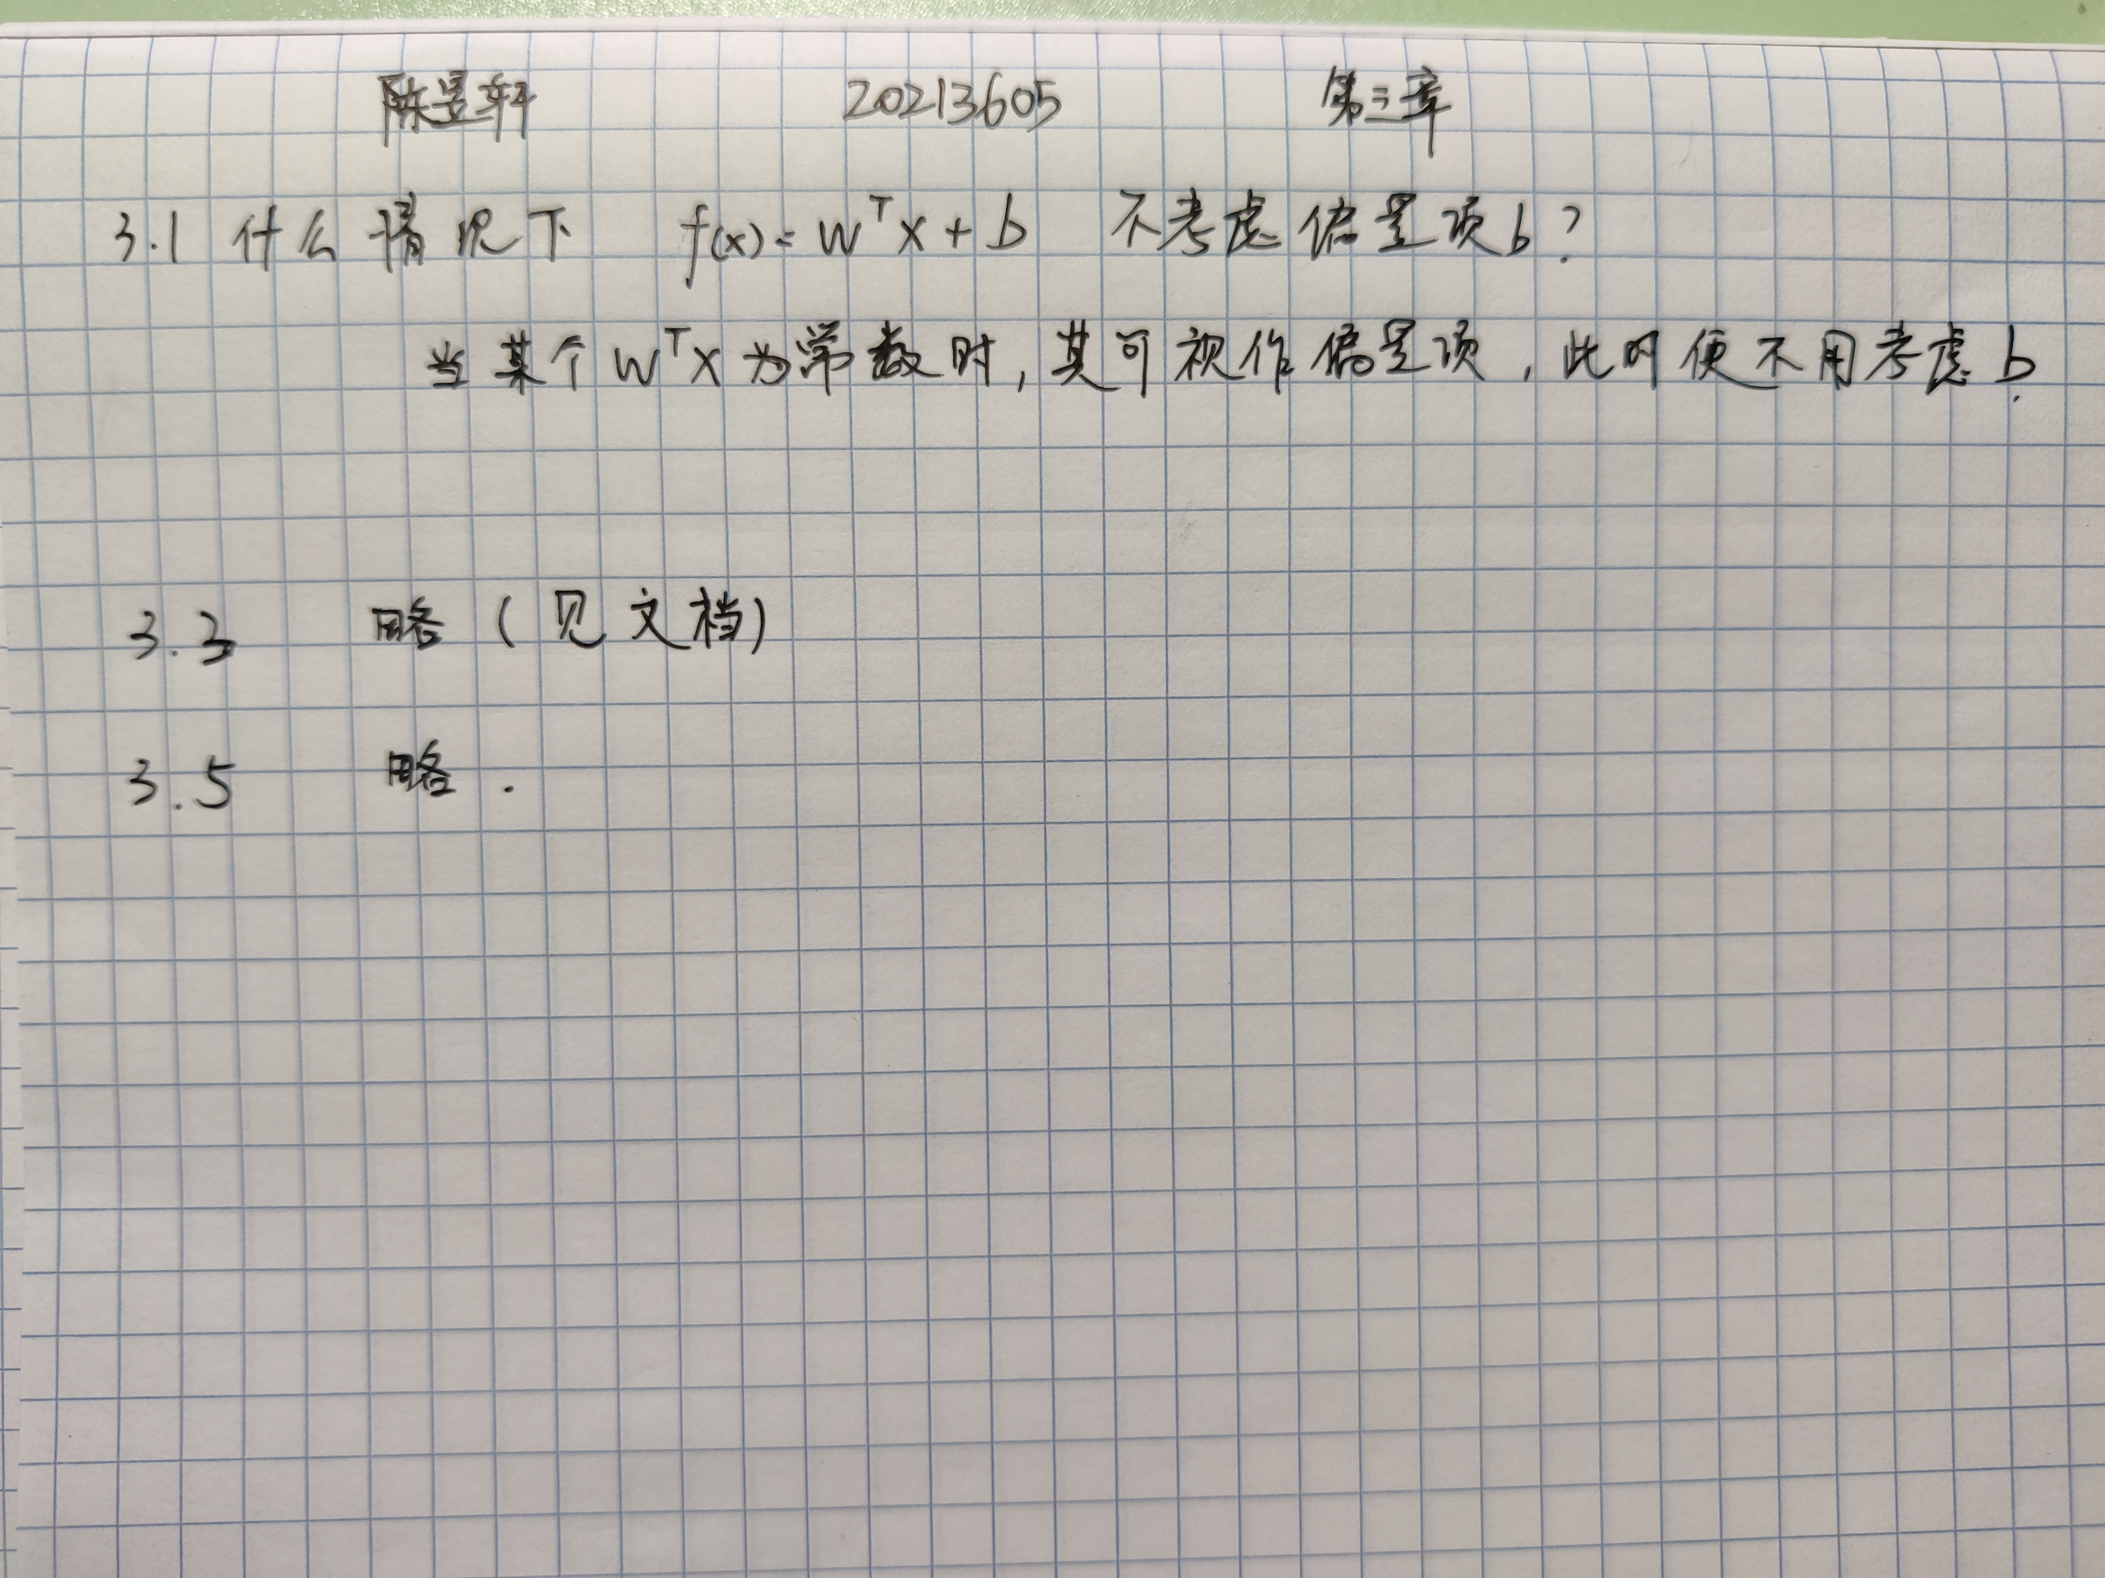

3.3 编程实现对率回归，并给出西瓜数据集3.0α上的结果

import numpy as np

from sklearn.datasets import load_iris

from sklearn.model_selection import train_test_split

class LogisticRegression:

def __init__(self, learning_rate=0.1, num_iterations=1000):#设置类的学习率和迭代次数的默认值为0.1和1000

self.learning_rate = learning_rate

self.num_iterations = num_iterations

def __add_intercept(self, X):

intercept = np.ones((X.shape[0], 1))

return np.concatenate((intercept, X), axis=1)#为输入的X数据集增加一列全为1的截距，返回增加截距项后的数据集。

def __sigmoid(self, z):

return 1 / (1 + np.exp(-z))

def fit(self, X, y):

#定义一个函数fit，用于训练逻辑回归模型。首先将X增加截距项，然后初始化theta参数为全0。

#接着，进行num_iterations次迭代，计算当前参数下的预测值，计算损失函数对参数的偏导数，更新参数theta。

X = self.__add_intercept(X)

self.theta = np.zeros(X.shape[1])

for i in range(self.num_iterations):

z = np.dot(X, self.theta)

h = self.__sigmoid(z)

gradient = np.dot(X.T, (h - y)) / y.size

self.theta -= self.learning_rate * gradient #这里是梯度下降法的核心公式，theta = theta - alpha * gradient，其中alpha是学习率，gradient是损失函数对参数的偏导数。

def predict(self, X):#定义一个函数predict，对输入的数据进行预测。首先对数据增加截距项，然后计算预测值，如果大于等于0.5，返回True，否则返回False。

X = self.__add_intercept(X)

return self.__sigmoid(np.dot(X, self.theta)) >= 0.5

iris = load_iris()

X = iris.data

y = (iris.target != 0) * 1

# 划分数据集

X_train, X_test, y_train, y_test = train_test_split(X, y, test_size=0.3, random_state=44)

model = LogisticRegression()

model.fit(X_train, y_train)

y_pred = model.predict(X_test)

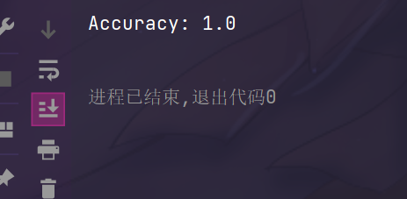print('Accuracy:', np.mean(y_pred == y_test))

3.5 编辑实现线性判别分析，并给出西瓜数据集 3.0α 上的结果

import pandas as pd

import numpy as np

import matplotlib.pyplot as plt

# 读取数据

data = pd.read_csv('3.1.csv')

# 提取特征和标签

X = data.iloc[:, 1:-1].values

y = data.iloc[:, -1].values

# 计算每个类别的均值向量

mean_vectors = []

for cl in range(2):

mean_vectors.append(np.mean(X[y==cl], axis=0))

# 计算类内散度矩阵

S_w = np.zeros((X.shape[1], X.shape[1]))

for cl, mv in zip(range(2), mean_vectors):

class_sc_mat = np.zeros((X.shape[1], X.shape[1]))

for row in X[y == cl]:

row, mv = row.reshape(X.shape[1], 1), mv.reshape(X.shape[1], 1)

class_sc_mat += (row - mv).dot((row - mv).T)

S_w += class_sc_mat

# 计算类间散度矩阵

overall_mean = np.mean(X, axis=0)

S_b = np.zeros((X.shape[1], X.shape[1]))

for i, mean_vec in enumerate(mean_vectors):

n = X[y==i,:].shape[0]

mean_vec = mean_vec.reshape(X.shape[1], 1)

overall_mean = overall_mean.reshape(X.shape[1], 1)

S_b += n * (mean_vec - overall_mean).dot((mean_vec - overall_mean).T)

# 计算广义特征值和特征向量

eig_vals, eig_vecs = np.linalg.eig(np.linalg.inv(S_w).dot(S_b))

# 将特征向量按照特征值从大到小排序

eig_pairs = [(np.abs(eig_vals[i]), eig_vecs[:,i]) for i in range(len(eig_vals))]

eig_pairs = sorted(eig_pairs, key=lambda k: k[0], reverse=True)

W = np.hstack((eig_pairs[0][1].reshape(X.shape[1],1), eig_pairs[1][1].reshape(X.shape[1],1)))

# 将数据投影到新的空间中

X_lda = X.dot(W)

# 绘制投影后的数据

plt.scatter(X_lda[:, 0], X_lda[:, 1], c=y)

plt.xlabel('LD1')

plt.ylabel('LD2')

plt.show()  
  
